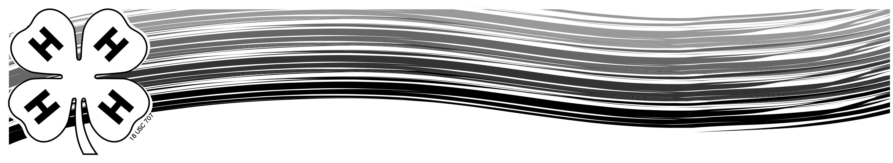
Ozaukee County 4-H Record Book Guidelines
The record book is a complete picture of your 4-H year. You will be surprised at how much you accomplish in 4-H! For each 4-H project and activity you participate in at club, county, state, or national level, you will enter it in this 4-H Record Book. If you need help, please ask your General Leader or project leader.

At the end of your 4-H year, you will hand this 4-H Record Book in to your Club’s General Leader according to your club policy. You will be evaluated on the accuracy and completeness of your Record Book and on your participation in 4-H. The Record Book is part of the achievement requirements in 4-H. Good luck and have a great 4-H year!

General Guidelines

*Remember! All members are required to complete a record book.
- BE ACCURATE and CLEAR.
- EMPHASIZE goals, learning, and responsibilities.
- BE NEAT. Print, write, or type your own record book.
- Record Books should be entirely the work of the 4-H member.
- Include only information from the current 4-H year. Old record sheets/books should be kept for reference when applying for trips, awards and scholarships.
- DO NOT include general items such as ribbons, project literature, program booklets, club or county newsletters.
- Have fun with your record book! This will be your way to share and remember this years 4-H projects and experiences.

4-H Record Book Order
- Record Book Cover (Green Binder)
- Introduction Page-include picture
- Permanent Record Pages-Keep in your record book year to year.*
  - Project Summary-Use one column per year. Include all projects enrolled in.
  - Leadership & Achievement Summary-Use separate line for each item.
- 4-H Club Activity Page-Provided by your 4-H Club. It includes a list of all the things you could have participated in for your club, county and state activities.
- My 4-H Story-a summary highlighting your year’s experience in projects, leadership and activities. Include your successes and challenges.
- Project Record Pages-Complete a project record sheet for each project in which you are enrolled. There are separate record pages for small and large animal projects, youth leadership, and Cloverbuds. All other projects use the general Ozaukee County 4-H Project Record Pages. Project photos or related project information should follow the reporting page
- Additional 4-H information can include photos, newspaper clippings or other information describing your involvement in 4-H.

* Your Permanent Record Pages are the only forms you will keep in your book from year to year.
All other pages should be removed and kept for your personal 4-H scrapbook after receiving new pages.

Ozaukee County 4-H Club Record Book
20

_______

Introduction

Member Name: |  |  |  |  |  |  |  |  |  | Age:
Club Name:
Grade (current year): |  |  |  |  | School Attending:
Years in 4-H
(Including the current 4-H year):
Parent Name(s):

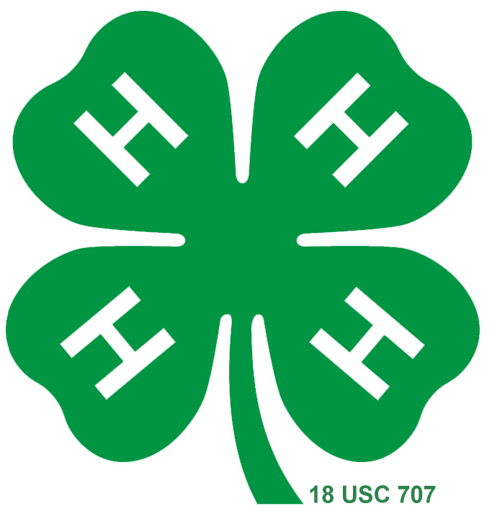

Insert
Picture Here

Ozaukee County 4-H Record Book Order

1. Introduction Page

2. Permanent Summary Pages
a. Project Summary
b. Leadership & Achievement Summary

3. 4-H Club Activity Page

4. 4-H Story Page(s)

5. Project Record Page
Project Meeting Dates Page
Project photo or related materials

6. Additional 4-H information

My 4-H Story

Your 4-H story is a summary highlighting this year’s 4-H experience.

Include the following:

      - 4-H experiences you enjoyed and why

      - Life skills you developed or improved
( (Examples-Patience, confidence, organization, etc.)

      - What you learned and accomplished

      - Leadership experiences and club involvement

      - What you hope to do and learn next year

Ozaukee County 4-H Record Page 20 _

Name: |  |  |  |  |  |  |  |  |  |  |  | Grade:
Project Name: |  |  |  |  |  |  |  |  |  | Years in Project:
Is there a leader for this project? |  |  |  |  |  |  | - Yes |  |  |  | - No
Family Assistance? |  |  |  |  |  |  | - Yes |  |  |  | - No
Number of project meetings held: |  |  |  |  |  |  |  |  | Number attended:
1. List your goal(s) in this project: |  |  |  |  |  |  |  |  |  |  |  |  | Accomplished Goal:
a. |  |  |  |  |  |  |  |  |  |  |  |  | - Yes  - No
b. |  |  |  |  |  |  |  |  |  |  |  |  | - Yes  - No
2. List what you learned and/or accomplished in this project.
3. What did you like most about this project?
4. Describe what you would change about this project or what you did in the project.

Project Items Made
List all items made throughout the project year. (If exhibited, include placing and location.)

Item | Time Spent | Total cost of completed project | Exhibited
Item | Time Spent | Total cost of completed project | Where | Placing

Project – Related Events
List tours, clinics or workshops, project talks, demonstrations, etc. that you participated in or attended

Date | Event/Topic | What did you do or learn?

Member signature: |  |  |  |  |  | Date:
Project Leader’s Signature: |  |  |  |  |  | Date:

Comments:
Parent’s Signature: |  |  |  |  |  | Date:

Comments:

Following the record sheet, add pictures, news articles or materials specifically related to this project to illustrate what you did in this project year.

Ozaukee County 4-H Project Summary

Keep this form with your record book throughout your 4-H career.
Name: |  |  |  |  |  |  | Phone Number:
Address: |  |  |  |  |  |  |  | Zip:
Birthdate: Month: |  |  |  |  |  | Day: |  |  | Year:
Parent/Guardian Name(s):
Name of Club:

Below are the projects, which I have enrolled in as a member. Use one column per year.
Please check (✓) which year(s) you took these projects.

Cloverbud | Year | Year | Year

Name of Project | Year  ____ | Year  ____ | Year  ____ | Year  ____ | Year  ____ | Year  ____ | Year  ____ | Year  ____ | Year  ____ | Year  ____ | Year  ____
(Continued)
Name of Project | Year  ____ | Year  ____ | Year  ____ | Year  ____ | Year  ____ | Year  ____ | Year  ____ | Year  ____ | Year  ____ | Year  ____ | Year  ____

Ozaukee County Permanent Record
4-H Leadership & Achievement Summary

Keep this form with your record book throughout your 4-H career.
Name:

Leadership Responsibility
Includes offices held, committees served on, camp counselor positions, ambassador position or any other leadership position. If you were chairman of a committee, indicate by writing CHR after committee served on. Trips, awards, contests, and other activities will be recorded on the next page.

Year | Leadership Responsibility | Club | County | Dist/State | Nat’l
Additional permanent record sheets available from the Extension office.
(Continued)
Leadership Responsibility – Continued

Year | Leadership Responsibility | Club | County | Dist/State | Nat’l

Trips, Awards, Scholarships, Contests above the club level
Includes 4-H Summer Camp, Wisconsin 4-H Youth Conference, Citizenship-Washington Focus, Wisconsin 4-H Key Award, International Trips, Mr./Miss Ozaukee 4-H, Foundation Scholarship, Etc.

Year | Achievement | Dist/County | State | Nat’l

Ozaukee County 4-H
Youth Leadership Project Record Page 20

Name: |  |  |  |  |  |  |  |  |  |  |  |  |  |  |  | Grade:

What project/activity are you a youth leader for?
How many years? |  |  |  | Is there an adult leader for this project/activity? |  |  |  |  |  |  |  |  |  |  |  |  |  |  |  |  |  |  | Yes |  |  | No
Are you in this project as a member? |  |  |  |  |  |  |  |  | Yes |  |  |  |  | No |  | How many years?
Number of project meetings held: |  |  |  |  |  |  |  |  |  | Number I attended:
Number of project meetings I planned and led: |  |  |  |  |  |  |  |  |  |  |  |  |  |  | Number of youth in group:
Number of youth I taught: |  |  |  |  |  | In a group: |  |  |  |  |  |  |  |  |  | 1 to 1 teaching:
1. List your youth leadership goal(s) in this project/activity: |  |  |  |  |  |  |  |  |  |  |  |  |  |  |  |  |  |  |  | Accomplished Goal:
a. |  |  |  |  |  |  |  |  |  |  |  |  |  |  |  |  |  |  | - Yes  - No
b. |  |  |  |  |  |  |  |  |  |  |  |  |  |  |  |  |  |  | - Yes  - No
2. What were your youth leader responsibilities? What did you teach, lead or demonstrate:
3. Describe the project meeting you planned and taught. What did the members learn?
How did you feel the meeting went?
4. What challenges did you have as a youth leader? Explain how you solved them.

5. What did you learn from being a youth leader in this project/activity?

Individual Project Listing
List all teaching or leadership items made this project year. If exhibited, placing and location.
Item | Time Spent | Total cost of completed project | Exhibited
Item | Time Spent | Total cost of completed project | Where | Placing

Project – Related Events
List tours, clinics or workshops, project talks, demonstrations, etc. that you lead or taught,
participated in or attended.
Date | Event/Topic | What did you do or learn?

Member signature: |  |  |  |  |  | Date:
Project Leader’s Signature: |  |  |  |  |  | Date:

Comments
Parent’s Signature |  |  |  |  |  | Date:

Comments:

Following the record sheet, add pictures, news articles or materials specifically related to this project to illustrate what you did in this project year.
Ozaukee County 4-H My 4-H Story
20_

A summary highlighting my 4-H experiences this year:
(Continued)

Ozaukee County 4-H
Project Meeting Dates 20_

Name of Project:
Number of meetings held: |  |  | Number of meetings I attended:

Give a brief description of each of the project meetings you attended. What did you learn from each topic or activity that was a part of your meeting?
Date of  Project Meeting | Topic/Activity | What I Learned or Did
(Continued)
Date of  Project Meeting | Topic/Activity | What I Learned or Did

My Ozaukee County

4-H Activity Program 20_
Name ___________________________________________Years in 4-H (include this year) _________________

Age on January 1, this year ______________________ Grade during 4-H year ___________________________

Number of meetings held by my club this year __________________Number I attended __________________

Club Activities | Describe | Approx. Date Completed
Demonstrations
Talks
Music/Drama
Judging
Recreation
4-H Promotion
Dairy Promotion
Community Service
Club Tour
Picnic
Officer
Committees

County Activities | Describe | Approx. Date Completed
4-H Variety Show/Aud.
Ambassador Program
Clothing Revue
Summer Camp
Fair Activities
Volleyball/Softball
4-H Promotion
Older Youth
Mr./Miss Ozaukee 4-H
Officer, Committees
Bowl-A-Thon
(Continued)

District, State, Nat’l | Describe | Approx. Date Completed

State Fair Demonstration
State Fair Clothing Revue
State Fair Exhibitor
Wisconsin 4-H Conference
Art Team/Drama/Showcase Singers
Citizen/Washington Focus
District/State Project Events
National Congress/Conference

